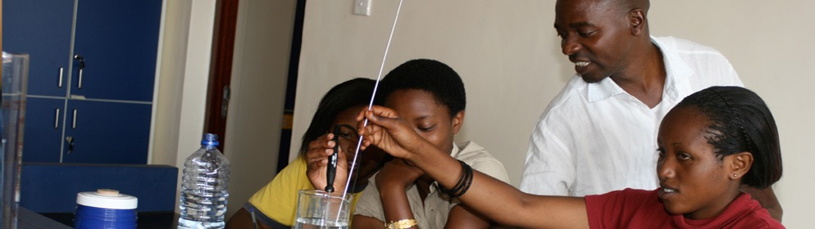

**Call for**

**Proposals**

|  |  |  |  |
| --- | --- | --- | --- |
|  | CATEGORY **❶ Emerging Educational Researcher** | |  |
|  | | Education Research in Africa Award | |

The Association for the Development of Education in Africa (ADEA) and the African Development Institute (ECAD) of the African Development Bank (AfDB) have launched this call for proposals within the framework of the third round of competition for the Education Research in Africa Award (ERAA), under the aegis of the Korea-Africa Economic Cooperation (KOAFEC).

**Purpose**

Recognizing the critical role of education in social and economic development, acknowledging the importance of research in the formulation and implementation of educational policy and reforms, and cognizant of the critical role of knowledge, experience, lessons learnt and their tangible impact on the sustainable and inclusive transformation of African economies, ADEA and ECAD/AfDB have created the **ERAA**.

This award is designed to promote excellence in educational research in African universities, research institutes and networks. It seeks to identify, reward and foster outstanding accomplishments in educational research in Africa, as well as its application in training or capacity building. More specifically, ERAA aims at:

* Strengthening the link between education research and education policy-making and practice in Africa;
* Encouraging and supporting Africa-based researchers and their institutions to produce and disseminate rigorous and relevant research that stimulates innovative policy-making for Africa;
* Facilitating interaction between researchers and policy-makers in order to promote the systematic use of research findings in policy conceptualization, formulation, design, implementation and evaluation;
* Facilitating the identification of strong researchers to provide content for the ADEA Knowledge Hub.

The expected long-term outcome of this award is the institutionalization of a culture of high quality and relevant educational research in Africa that contributes to informed decision-making, and effective implementation of reforms and practice.

**Eligibility criteria**

An African researcher based in Africa, aged 35 maximum on December 31, 2018, who conducted and published at least one outstanding and relevant piece of research in education, training or capacity building can compete in this category[1].

**Criteria for evaluating submissions**

The following criteria will be used to assess the quality of submissions and select the recipients:

* The topic of the research must be a subject of interest to the educational research community and/or relevant to education policy making.
  + Research submissions addressing the following thematic areas will receive special consideration: Technical and Vocational Skills Development (TVSD), Early Childhood Development, ICTs, Science, Technology and Innovation (STI), Gender, Peace, Inclusive Education, Teacher Education and the Teaching Profession.
  + For this third round of competition, special attention will also be given to education, training or capacity building works related to the African Development Bank’s five operational priorities known as High 5s: energy, food and agriculture, industrialization, continental integration and improving the quality of life for the people (see <https://www.afdb.org/en/the-high-5/> for more information on these priorities).
* The degree to which the research product contributes to knowledge advancement OR may contribute to policy development or implementation or capacity building.
* The degree to which the research reported meets all basic criteria of good research (problem statement, theory/concepts, methodological design, analysis, interpretation, etc.).
* Indication that the researcher holds the potential to further her/his career if provided with the enabling environment and resources, including refereed publications and presentations at academic or professional meetings prior to obtaining highest degree, papers related to education, training or capacity building since starting research career, membership of academic and/or professional organizations and networks related to education, training or capacity building, etc.).

***NB:*** *Creativity and originality of the piece of research is an added advantage.*

The submission with the highest grades will be retained for the award. ADEA and ECAD/AfDB reserve the right not to give out the award if no submission obtains the pass grade of 75%.

**Content of application dossier**

1. A completed application form (see p. 4 of this call)
2. A statement of justification/merit (not to exceed one single-spaced page), including indications of candidate’s scientific interests and ambitions for her or his academic/professional future.
3. A maximum two-page CV focusing on research experience
4. Two letters of support[2]
5. A scanned copy of a national identity document indicating the date of birth
6. Evidence of residence in Africa
7. An electronic copy (in Microsoft word or pdf) of the research output being submitted for consideration (including a 2-3 page executive summary) with full reference of the source.

***NB:*** *Candidates can submit one (only) research product such as a book chapter or a peer-reviewed article, based on empirical research or on in-depth analysis of existing literature and offering implications for educational theory, policy and practice (published or accepted for publication by a reputable academic press or a journal). Co-authored entries must be accompanied by authorizations signed by the co-authors.*

**Language of submission**

Submissions are accepted in English or French.

**Deadline for submitting application dossiers**

Application dossiers must be submitted electronically no later than **October 15, 2018 at 11:59 pm GMT** to the following address: [**eraa@afdb.org**](mailto:eraa@afdb.org)**.**

***NB****: Dossiers received after the above-mentioned deadline will not be considered. Also, any dossier that is incomplete or contains false information will be automatically rejected.*

**Composition of the award**

The award is made up of monetary and in-kind components.

**For further information**, please send an email to [eraa@afdb.org](mailto:eraa@afdb.org) or call Mrs. Raky Gassama at (225) 20 26 12 07.

**APPLICATION FORM**

|  |  |  |  |
| --- | --- | --- | --- |
|  | CATEGORY **❶ Emerging Educational Researcher** | |  |
|  | | Education Research in Africa Award | |

1. Surname and first name(s): _____________________________________________________________
2. Contact address: _____________________________________________________________________

____________________________________________________________________________________

1. Gender: Female  Male 
2. Current position: ______________________________________________________________________
3. Current institutional affiliation: __________________________________________________________
4. Nationality: __________________________________________________________________________
5. Country of residence: __________________________________________________________________
6. Language proficiency: (4 = functional native; 3 = advanced professional; 2 = general professional; 1 = limited)

|  |  |  |  |  |
| --- | --- | --- | --- | --- |
|  |  | **Speaking** | **Reading** | **Writing** |
|  | **English** |  |  |  |
|  | **French** |  |  |  |
| **Others:** |  |  |  |  |
|  |  |  |  |

1. Title of the piece of research submitted for competition and date of publication:

____________________________________________________________________________________

____________________________________________________________________________________

1. Main research areas/topics: _____________________________________________________________

____________________________________________________________________________________

1. Full name of Master’s degree or PhD advisor and degree granting institution:

____________________________________________________________________________________

____________________________________________________________________________________

1. Referees:

|  |  |
| --- | --- |
| Surname & first name(s) | Contact address, including email and/or fax number |
|  |  |
|  |  |

1. Membership of academic and/or professional organizations and networks related to education, training or capacity building:

|  |
| --- |
|  |

|  |  |  |
| --- | --- | --- |
|  |  |  |
| Signature |  | Date |

1. Awards will be granted in three other categories: accomplished educational researcher, outstanding mentor of educational researchers, and enabling institutional environment for educational research.
2. The referees must be individuals who are in a position to assess the value of the candidate’s work for the scientific community and/or for policy and practice. They must send their letters directly to the email address provided below. It is the candidate’s responsibility to request these letters and inform her or his referees about the eligibility and evaluation criteria, as well as the deadline for submitting application files.